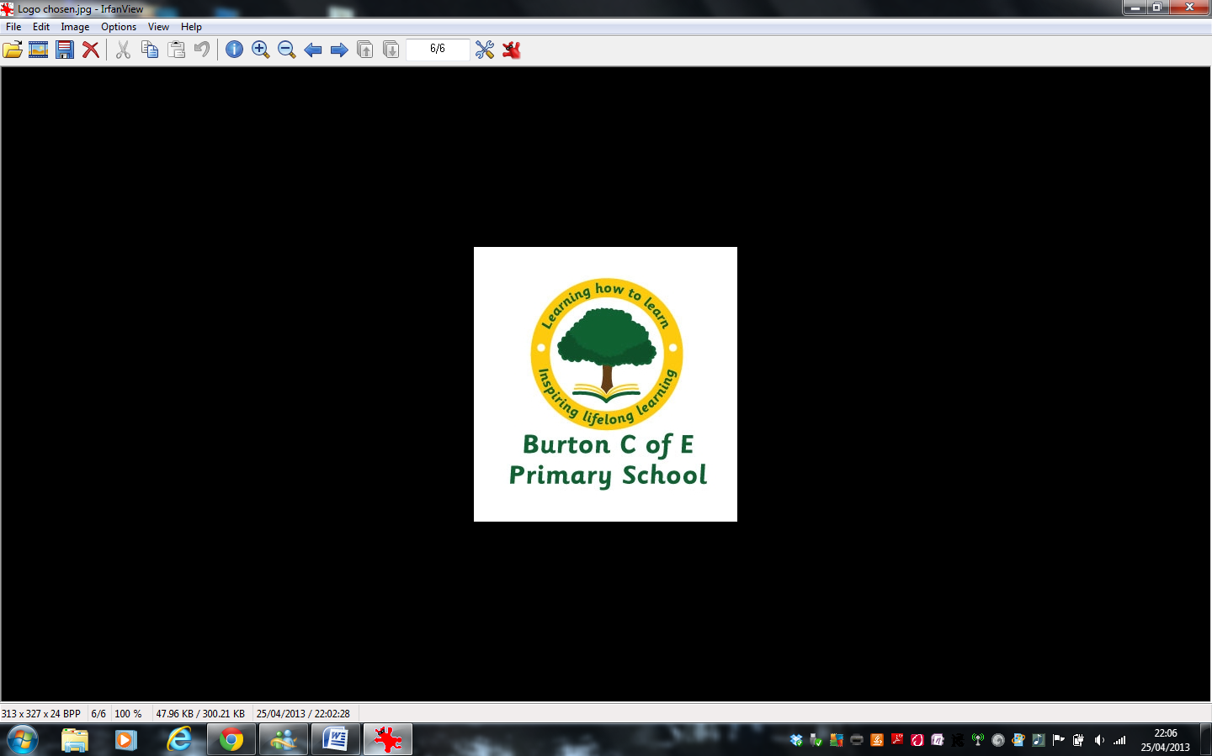

Digital Literacy
Passport

Change Name Here

Key Stage 1

By the end of Year 2, I will be able to show all of these key skills to keep me productive in the digital world!
Skill | Evidence seen |  |  | Signed by:
I can turn on a computer.
I can login to a computer.
I can use a track/mouse pad.
I can use left click to select.
I can save my work to a file.
I can open my work from a file.

I can use letter, number, and space keys.

I can delete letters.
I can type capital letters.

I can use a computer to launch an application.

By the end of Year 4, I will be able to show all of these key skills to keep me productive in the digital world, and help me prepare for the use of technology in UKS2.

Skill | Evidence seen |  |  | Signed by:
I can change the font.
I can select a word by double-clicking .

I can identify the toolbar and use bold, italic, and underline.
I can explain that digital devices accept inputs.

I can explain that digital devices produce outputs.

I can access websites on the WWW.
I can add and format images within a document.
I can use software tools to check spelling and grammar.
Lower Key Stage 2

Digital Literacy
Passport

Change Name Here
Lower Key Stage 2

Key Stage 2

Digital Literacy
Passport

Change Name Here

Stage 2

By the end of Year 6, I will be able to show all of these key skills to keep me productive in the digital world, and help prepare me for my future education and lifelong digital learning.
Skill | Evidence seen |  |  | Signed by:
I can refine my web search.

I can compare results from different search engines.

I can use word processing software to plan digital content or projects.
I can use spreadsheet software to export data to create charts and graphs.
I can improve and refine my work using the formatting tools available.
I can design and create digital content using appropriate software.
I can use the ctrl v and ctrl c keyboard shortcuts.

