Situation  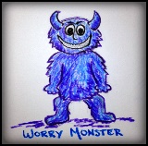 | Rate the worry monster on a scale of 0-10  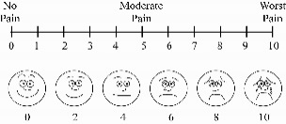  This Photo by Unknown Author is licensed under CC BY-SA |   Worrying thought  This Photo by Unknown Author is licensed under CC BY-NC-ND |   Proof for worry (only facts)  This Photo by Unknown Author is licensed under CC BY-NC-ND | Proof against worry (only facts)  This Photo by Unknown Author is licensed under CC BY-NC-ND | 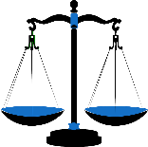  Balanced thought | Rate the worry monster on a scale of 0-10  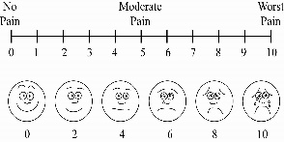  This Photo by Unknown Author is licensed under CC BY-SA

